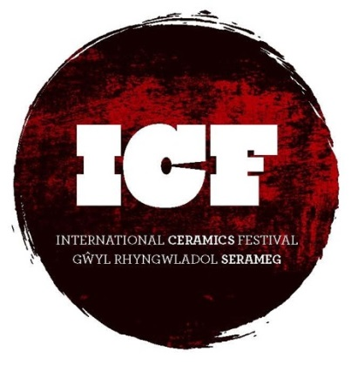

International Ceramics Festival

Aberystwyth Arts Centre

Aberystwyth University

Aberystwyth

Ceredigion

SY23 3DE

www.internationalceramicsfestival.org
Email: aafstaff@aber.ac.uk
Tel: 07531146638

ICF Brochure Advertising Fees 2017
The ICF produces a full colour 24 page A4 Festival brochure which is issued during every festival to an audience of approximately 1000 individuals. It includes the full programme of events plus listings for all trade stands in attendance as well as profiles of the guest demonstrators and lectures. It is often kept as a souvenir of the festival when visitors return home. After each Festival it is uploaded to the Festival Website where it is archived for anyone to download as a PDF to read at their leisure.
Adverts can be in the format A4, ½ page or ¼ page (landscape or portrait). Fees start from £130
We also offer the service of inserting flyers in to ICF souvenir bags that are issued during each festival with prices starting at £75 for 1000 A5 flyers.
Full remittance for adverts should be sent with a copy by 31st March 2017, cheques made payable to International Potters Camp Ltd. Please contact us to pay by BACS.
For all marketing enquiries please contact Louise Chennell mailto:marketing@icfaberystwyth.org
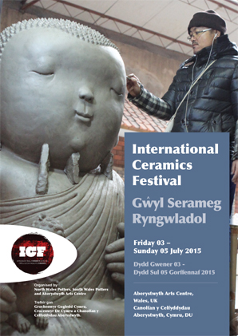

Full page  190mm width  280mm height  £260 | Quarter page portrait  95mm width  140mm height  £130
Half page landscape
190mm width
140mm height
£200

