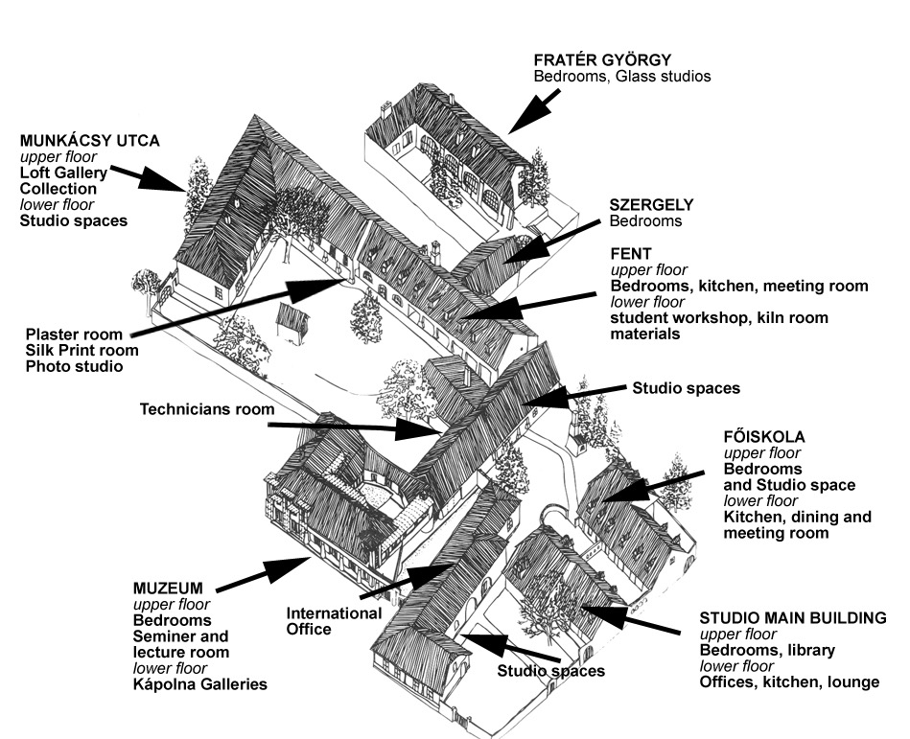

The International Ceramics Studio (ICS) is a ceramic art centre located eighty kilometres south of the Hungarian capital, Budapest. The centre was created 40 years ago on the initiative of Hungarian artists who had felt culturally and ideologically isolated by the political system of that time. It was the wish for freedom and the desire to work alongside international artists that led to the founding of the centre. Since its establishment it has welcomed over 350 artists from all corners of the world and boasts an impressive collection of over 3500 works of contemporary ceramics in its recently opened museum.

The mission of the studio is to promote the formal, aesthetic and technical development of ceramics and to help foster creative skills. The studio is open to all challenges of ceramic research, design and experiment. With this in mind the ICS offers modern facilities and kilns, ample studio space and technical support.

Since 2011 The ICS, together with the Forrás Publishing House and the International Studio of Enamel Art, belongs to the Kecskemét Contemporary Art Studios. The International Ceramics Studio is a non-profit making company owned and supported by the City of Kecskemét.

Working as Artist-in-Residence

The Artist-in-Residence program is open to all artists who wish to work independently on their own projects. Artists may use the residency to accomplish a specific project or to work in a creative and supportive atmosphere alongside other international ceramic artists. The luxury of time and the studio environment allows for intense periods of creativity free from the distractions of everyday pressures.

The ICS Artist-in-residence program allows artists to work in the context of a different country and culture. We have created, here in Kecskemét, a centre of international cultural exchange, allowing artists to work alongside others from a variety of rich and culturally diverse backgrounds as well as local arts professionals and students.

The programmes provide artists with the space to create new works, experiment with innovative ideas, explore new directions in their work and research new and different ways of making. Artists are encouraged to explore all our facilities to open up new possibilities and directions for the contemporary ceramist. Resident artists are able to exchange ideas and experiences through presentations and informal discussion.

On average there are up to ten artists in residence at the ICS at any one time. There are plenty of opportunities to interact with the other artists but enough space to be quiet and reflective.

Making an application
Applications for the Residency award are open to all ceramic practitioners including mid-career and late adopters of ceramics wishing to work in a rich and cultural environment. Applicants must be based in the United Kingdom.

THE DEADLINE FOR APPLICATIONS IS 30th APRIL, 2019

Please state which time you wish your residency period to commence and finish and wherever possible we will try to accommodate you at your chosen time.

- Please send the completed application form
- 6 clearly labelled digital images
- your CV (Resumé)
- a brief statement about what you hope to accomplish during your residency.

Applications are only accepted by email to icshu@me.com.

Accommodation

Rooms are simply furnished with bed, desk, chairs, wardrobe and cupboard and supplied with clean bed-linen, pillows and towels. Accommodation is in single rooms with shared facilities or we have a limited number of single en-suite rooms with their own shower and WC at a small supplement cost.

Artists have the use of modern, fully equipped kitchens with large, shared refrigerators, cookers and microwave ovens. All cups, plates, cooking pots, saucepans and cutlery is provided. There are spacious lounges and dining rooms. All accommodation is self catering.

Studios and workshops

Studios are provided for single, double or larger shared workshop spaces. There is water in most studios, tables and chairs as you need and central heating. Artists have 24 hour access to the workshops. In addition to the clay studios we have a fully equipped plaster workshop for model and mould making. We have a silkscreen printing facility for direct and indirect print including vacuum print bed, photo exposure screen and pressure washer. There is a fully equipped lecture and conference room with TV, video and DVD, digital and slide projectors and possibilities for laptop presentations to large screen TV. All artists in residence are requested to give a talk about their work to the other artists working here.

We have an extensive library of ceramic books and magazines as well as other art publications. There is free wi-fi in most areas.

Materials and equipment

There are slabrollers, electric and kick wheels, extruders, pugmills, ballmills etc. provided for artist’s use and we have 10 electric kilns of varying sizes, three gas kilns (firing to 1400c for porcelain), 4 wood-fired kilns one of which is for salt, and several raku kilns.

We stock a variety of clays including

- KS21 a stoneware chamotte (grogged) body
- White and various coloured Creaton chamotte or smooth textured clays
- Two kinds of porcelain, one of extremely high quality, fine and translucent only available in Europe here at the studio. Both porcelains are available as plastic clay and slip.

Conditions

- All participants must be insured for medical and personal liability for the duration of their residency at ICS. For European Union citizens please bring your EU Healthcard.
- During the residency period most artists will give presentations or talks about their work to the other resident artists or participants in ICS programmes. Please bring slides or images on cd or dvd
- During the work period the ICS may document and publish the work of the artist in publications or on the ICS website.
- At the end of the work period the ICS reserves the right to select representational pieces of work of the artist made during the residency for possible addition to the ICS collection. All other works are the property of the artist.
- ICS cannot offer storage for any artist’s works after the residency period is completed.
- The artist has the obligation to state at exhibitions or in publications concerning work produced during their residency that the work was created at the International Ceramics Studio.
- We also ask you NOT to send materials, tools or anything to ICS in a parcel by mail because of excessive customs fees and other difficulties. Please, bring everything with you in your luggage! Please contact Steve for assistance.
- The winner of the award will be notified and will be given a free ticket to attend the ICF 2019 where they will receive the award.
- The residency must be completed before December 2020 and the participant must be available to attend the International Ceramics Festival at Aberystwyth in 2021 to give a presentation about their residency.

Fees for materials and firings

Payment for materials and firings will be charged at the end of the work period depending on the materials used. Current prices can be found on our website and attached to this information sheet. All prices are in Hungarian Forints.

Organised programs and masterclasses

Alongside our Artist in Residence program we also have a series of organised, thematic workshop and events. Artists in residence may like to consider these programs when scheduling their residency time. It may be that some programs will be interesting or relevant to your work. Participation in some organised workshop programs may require an additional participation fee. Please see the program pages on our website for information.

Application for the Aberystwyth Ceramics Festival – Kecskemét Residency Award 2017

Please send applications by email to:
icshu@me.com

Personal Details

Name |  |  |  | male | female
Postal address

Telephone
Fax
Email
Nationality |  | Date of Birth

Your work program details

Please give us an idea of when you would ideally like your work period at ICS.
from |  | to
Please indicate the type of accommodation you require
Single room  with shared bathroom (included in the award) |  |  | Single room  with private bathroom (if you wish a private bathroom there is a supplement payment)

Project Description (if appropriate)
Please give a brief description of any particular proposals for your work period at ICS. We fully understand that work proposals may change during your residency but it helps to prepare us or advise you of the practicalities of any works you propose. (please use a separate sheet)

Applicants signature …………………………………………………… Date ………………………..

MATERIALS AND FIRING FEES

Electric Kilns | approx. size cms | up to 1000°c | over 1000°c
NR1 | 25 x 25 x 25 | 4,953 | 6,731
NR2 | 50 x 80 x 100 | 13,945 | 18,542
NR4 | 38 x 40 x 40 | 9,525 | 12,573
NR5 | 60 x 90 x 115 | 29,210 | 37,953
NR6 | 25 x 25 x 25 | 4,445 | 5,969
NR7 | 35 x 40 x 40 | 6,985 | 9,271
NR8 | 53 x 68 x 70 | 13,945 | 18,542
NR9 KKA | 30 x 40 x 50 | 6,350 | 8,509
NR10 | 35 x 40 x 35 | 3,556 | 4,699
NR11 | 53 x 68 x 70 | 15,240 | 20,193

Gas Kilns
GK1 | 70 x 70 x 110 | 67,564 | 93,218
GK2 | 100 x 100 x 120 | 112,903 | 151,384
GK3 | 81 x 56 x 56 |  | 31,115
GK4 NABER |  |  | 50,000

Wood-fired Kilns
Kusakabe Smokeless Kiln | 80x40x140 |  | 65,000
Olsen Super E | 80 x 80 x 100 |  | 70,000
Olsen kiln 1 - Fast Fire | 80 x 80 x 110 |  | 80,000
Olsen kiln 2 - Fast fire salt kiln | 80 x 80 x 110 |  | 80,000

Raku Kilns
Normal raku |  |  | 12,827
Oil reduction raku |  |  | 17,526
Small Round raku |  |  | 5,842
Large round raku |  |  | 12,827
Materials – Clay and Glazes
Clay – various kinds | 400 – 1200 huf per kilo
Glaze materials | 1000 – 4000 huf per kilo depending on materials

Kilns are usually fired by groups of participating artists so the relative costs can be reduced by shared kiln space. Wood kiln prices include the cost of wood and labour to fire. The clays are the standard range stocked by us. It is also possible to mix individual clay bodies at your request, but we kindly ask you to send information in advance to determine if we have the materials or not. Some materials may not be available in Hungary.

